Appendix A-11: Safe and Seamless Mobility Quick-Strike Program

The Safe and Seamless Mobility Quick-Strike program is a one-time, competitive grant program within the One Bay Area Grant program (OBAG 2) framework. Federal funding is available to support local and regional projects that can be implemented quickly to benefit communities responding and adapting to the COVID-19 environment.

Available funding includes a mix of Surface Transportation Block Grant Program (STP), Congestion Mitigation and Air Quality Improvement (CMAQ) and Federal Highway Infrastructure Program (FHIP) funds, with FHIP funds exchanged with STP/CMAQ funds to the extent possible to meet federal other funding deadlines and requirements. CMAQ funds will be used for eligible projects that demonstrate air quality benefits and implement Plan Bay Area’s climate initiative goals and priorities.

Project Eligibility & Focus Areas
The program emphasizes bicycle/pedestrian safety and mobility, connections to transit, and projects that advance equitable mobility. Eligible project types include:
- Quick-build bike, pedestrian, and transit improvements; including bike share enhancements.
- Local safe and seamless mobility projects, including projects that advance equitable mobility; invest in bicycle/pedestrian safety; improve connections to transit; or implement seamless strategies within a corridor.
- In addition to capital projects, programs that support safe and seamless mobility or advance equitable mobility are also eligible (ex. safe routes to school/transit programs); a limited amount of funding, (up to $200,000 per county) may also be directed towards countywide implementation of safe and seamless mobility planning and programming efforts).
- Other near-term implementation of strategies emerging from the Blue-Ribbon Transit Recovery Task Force and Partnership Board’s Connected Mobility Subcommittee.

Fund commitments for specific focus areas include:
- One-quarter of the total program is targeted for bicycle/pedestrian safety (including local road safety).
- $5 million is set aside to support early implementation efforts anticipated from the Blue-Ribbon Transit Recovery Task Force.
- $15.3 million directed to regional and corridor co-nominated projects and projects of interest to the Blue-Ribbon Transit Recovery Task Force.
- $1.9 million is set aside for ongoing CTA planning and programming activities
- $1.9 million is set aside for regional planning and programming activities, including Priority Development Area (PDA) planning and implementation and the FasTrak START Pilot program evaluation

Evaluation Criteria
MTC staff will evaluate nominated projects against the following program criteria.
Nominated projects should:
- Align with Connected Mobility Framework Values and Goals (see inset below)
- Be the direct result or outcome of a community engagement process
- Be within or directly connected to a Priority Development Area (PDA) or Transportation Priority Area (TPA) and/or serve a Community of Concern (CoC), Community Air Risk Evaluation (CARE) program area, or similar local designation. PDAs and TPAs may be existing or recently designated as part of the Plan Bay Area 2050 growth framework.
- Addresses transit connectivity gaps, especially in areas significantly impacted from the pandemic
- Demonstrate partnership among jurisdictions, transit agencies, and counties.
- Demonstrate ability to quickly deliver, and meet federal funding requirements, as funds must be obligated by September 30, 2022.

To ensure consistency with the implementation of county and regional plans and priorities, as well as encourage discussion and coordination in developing investment proposals, projects co-nominated by MTC and a CTA will be given extra consideration if meeting regional goals and priorities. Previously submitted co-nominated projects are to be funded out of the regional and corridor program component. New co-nominated projects may be funded out of either program.

Below are the regional connected mobility values and goals guiding these investments:
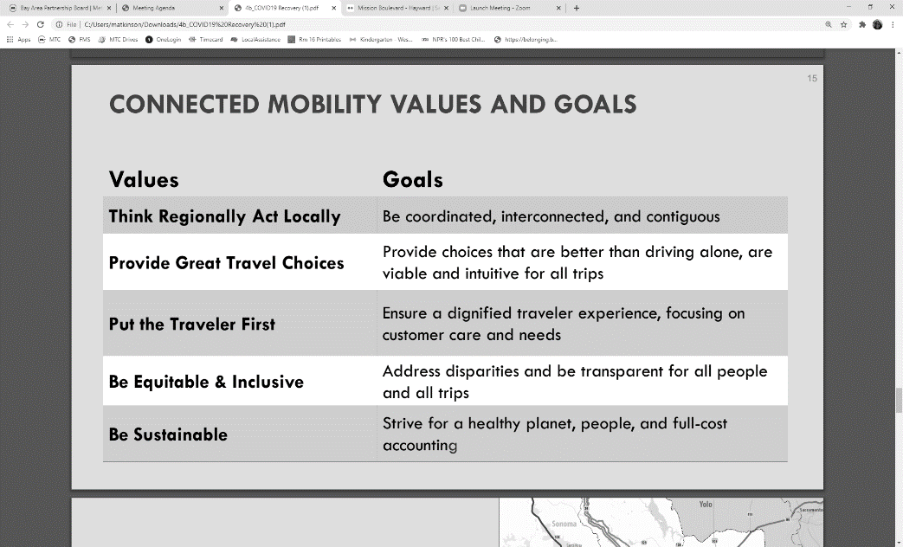

Project Nominations
To address local needs throughout the region, and encourage community-based project investments, each County Transportation Agency (CTA) will act on MTC’s behalf and submit project nominations for their county area. County targets have been provided as a guide, for each county (see table on following page). However, final project selection by MTC will not necessarily adhere to these targets. Target amounts are based on the OBAG 2 county program distribution.

In addition to county submissions, MTC may consider projects that would be implemented regionwide or in more than one county. Where applicable, MTC staff will work with CTAs to coordinate on co-nominations for regional projects. Previously co-nominated projects are to be funded out of the regional and corridor program component. New co-nominated projects may be funded out of either program.
County Nomination Targets
($ millions, rounded)
 | %
Alameda | 19.9%
Contra Costa | 14.6%
Marin | 2.8%
Napa | 2.1%
San Francisco | 12.5%
San Mateo | 8.4%
Santa Clara | 27.0%
Solano | 5.5%
Sonoma | 7.2%
 | 100.0%
Note: Final project selection and fund programming will not correspond exactly to nomination targets.

As the final program of projects must reflect regional or multi-county priorities, in addition to local priorities within each county, the final programming per county will not correspond exactly to nomination targets.

To ensure each county is provided sufficient funding to have a meaningful community impact, each county’s nomination target will be a minimum of $1 million.

Project Selection Process
The prioritization process is designed to quickly distribute funds to competitive and impactful investments throughout the region.
- Letters of Interest: County Transportation Agencies (CTAs) submit Letters of Interest to nominate projects within their counties. In addition to basic project information (project description, sponsor, total cost, funding request), submittals should also describe how the project meets the program eligibility requirements and evaluation criteria, and how well the proposed project sponsor meets state and federal funding requirements.

- Evaluation: MTC staff evaluate CTA nominations as well as regional program considerations to develop a recommended program of projects. Program recommendations presented to Bay Area Partnership Board for review and discussion.

- Project Applications: MTC and CTA staff work with project sponsors to submit project applications with a detailed scope, delivery schedule, and funding plan.

- Program Approval: MTC Commission consideration and approval of projects and fund programming.

Programming Policies and Requirements
Unless otherwise noted within these guidelines, OBAG 2 General Programming Policies (see MTC Resolution No. 4202, Attachment A, pages 6-11), and Regional Project Funding Delivery Policy (MTC Resolution No. 3606) apply.

- Project sponsors: Eligible sponsors are those approved by Caltrans to receive FHWA federal-aid funds (including cities, counties, transit agencies, CTAs, and MTC). Sponsors must also have a demonstrated ability to meet timely use of funds deadlines and requirements (see Project Delivery and Monitoring, below).

- Minimum Grant Size: Project nominations should be consistent with OBAG 2 minimum grant size requirements per county ($500,000 grant minimum for counties with population over 1 million, and $250,000 minimum for all other counties). Final funding awards may deviate from grant minimums per county, should one or more grant awards span multiple counties or regionwide.

Additionally, deviations from the OBAG 2 minimum grant size requirements for project nominations may be considered on a project-by-project basis. However, grant awards must be at least $100,000.

- Local Match: Toll credits may be requested in lieu of non-federal cash match.

- Supplanting of Funds Prohibited: Supplanting of existing funds on fully-funded projects is prohibited, as the program is intended to infuse transportation investment into communities responding and adapting to the COVID-19 environment. If funds are requested to address a funding shortfall on a project due to reduced local revenues, CTAs must demonstrate why the project should be a priority for regional funding, if it was not the highest priority for available local funding. In their nomination, CTAs should describe how the county and local jurisdictions determined which projects are prioritized for reduced local revenues.

- Project Phases: The Environmental (ENV), Plans, Specifications and Estimates (PS&E), Preliminary Engineering (PE) and Right Of Way (ROW) phases are eligible for capital projects as long as the construction (CON) phase of the project is delivered and funds obligated by September 30, 2022.

- Project Delivery and Monitoring: Project sponsors must have a record of consistently meeting state and federal timely use of funds deadlines and requirements, or demonstrate/identify revised/new internal processes to ensure they will meet funding deadlines and requirements moving forward at the time of project nomination. In addition to the provisions of the Regional Project Funding Delivery Policy (MTC Resolution No. 3606), the following specific funding deadlines/requirements apply:
  - Funds must be obligated (authorized in a federal E-76, or transferred to FTA) no later than September 30, 2022.
  - Funds must be encumbered or awarded in a contract within 6 months of federal obligation.
  - Funds must be invoiced against within 3 months of encumbrance/award and invoiced against and receive a federal reimbursement quarterly thereafter.
  - If there could be complications with invoicing against the construction phase within 9 months of federal obligation, then the sponsor should consider including Construction Engineering (CE) in the federal obligation so that eligible costs may be invoiced in order to meet the invoicing deadline.
  - Project sponsor must meet all other timely use of funds deadlines and requirements, for all other state and federal transportation funds received by the agency, during the duration of project implementation (such as, but not limited to, project award, federal invoicing, and project reporting).
  - To help ensure compliance with state and federal invoicing requirements, as part of the application submittal, the Finance/Accounting Manager/Director for the agency receiving the funds must provide written documentation on the agency’s internal process and procedures for complying with FHWA federal-aid timely use of funds requirements, especially with regards to meeting federal invoicing requirements.
  - CTAs nominating successful projects must monitor the project sponsors within their respective county in meeting the timely use of funds deadline requirements in MTC Resolution No. 3606 and report quarterly to MTC on the agency’s status in meeting regional, state, and federal timely use of funds deadlines and requirements.

- Additional Requirements Apply:
  - Project sponsor must comply with MTC’s Complete Street Policy and submit a Complete Streets Checklist for the project.
  - Project sponsor must adopt a Resolution of Local Support prior to adding the project into the Transportation Improvement Program (TIP).
  - Project sponsor must satisfy the OBAG 2 housing policy requirements – have a certified Housing Element, submit the Annual Progress Report for the Housing Element, and have adopted a resolution affirming compliance with the California Surplus Lands Act.
  - CTAs must make each project’s Complete Streets Checklist available for review by the appropriate Bicycle and Pedestrian Advisory Committee (BPAC) prior to MTC Commission approval of projects and fund programming. Documentation this has occurred must be included with the project application.

